1. **Write a Python Program to Find LCM?**

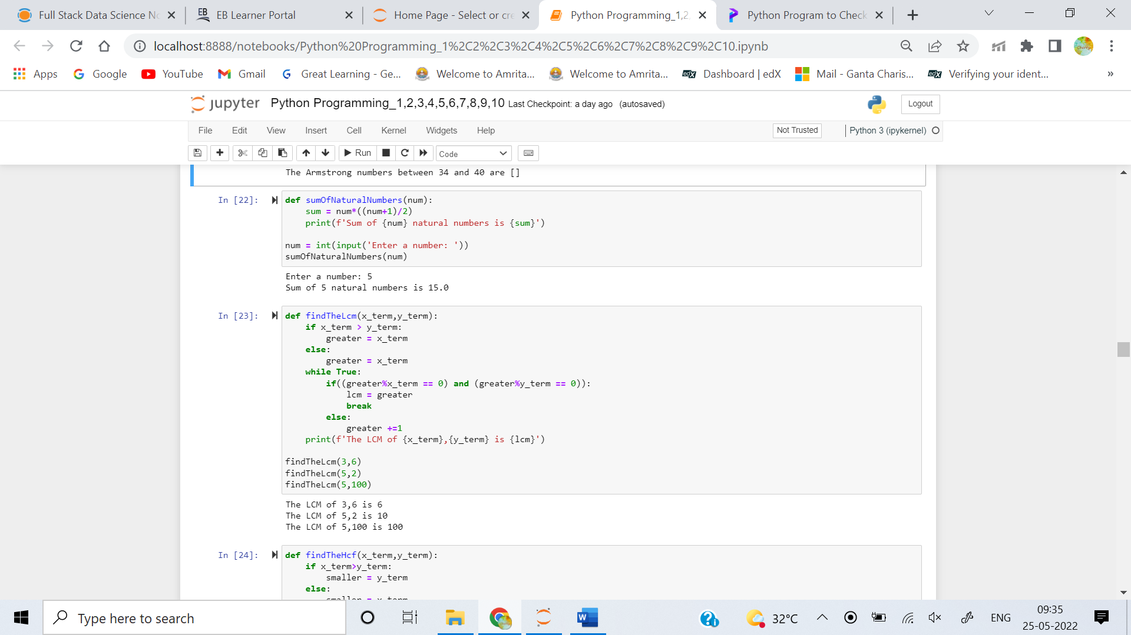

1. **Write a Python Program to Find HCF?**

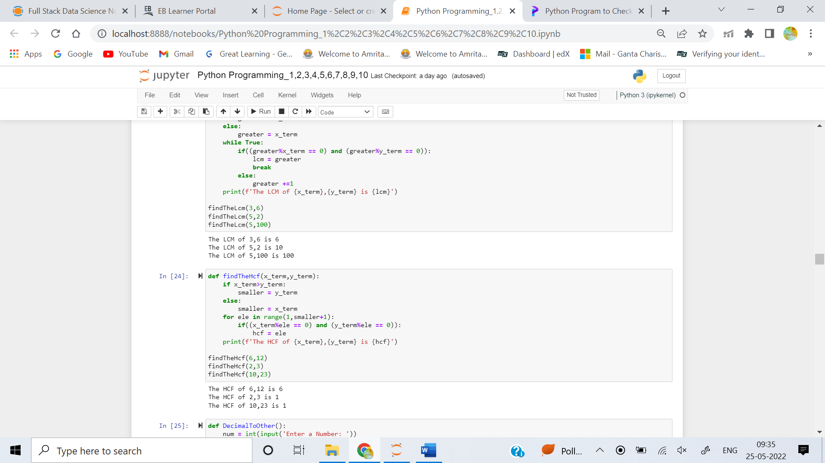

1. **Write a Python Program to Convert Decimal to Binary, Octal and Hexadecimal?**

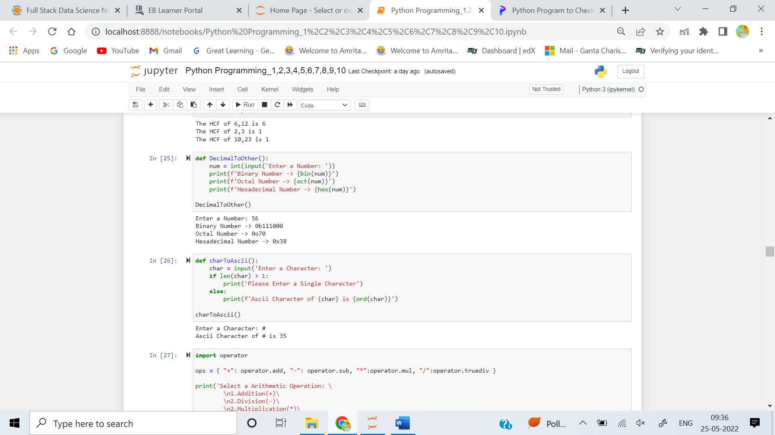

1. **Write a Python Program To Find ASCII value of a character?**



1. **Write a Python Program to Make a Simple Calculator with 4 basic mathematical operations?**

